Ultimate Power Dressing, 14 September 2017
The 1980s may have been the era of sharp suits and shoulder pads, but dressing to demonstrate wealth and influence has ancient roots. Step inside the wardrobes of China’s last great dynasty and discover how the Qing emperors and their courtiers flaunted and enhanced their social status through clothing.
Expert and collector David Rosier deliver a talk on how highly decorative costume at the Chinese court denoted the rank and status of the wearer. The talk will be accompanied by an exhibition of genuine imperial artefacts from David’s own collection.
This event is held in collaboration with the Meridian Society.
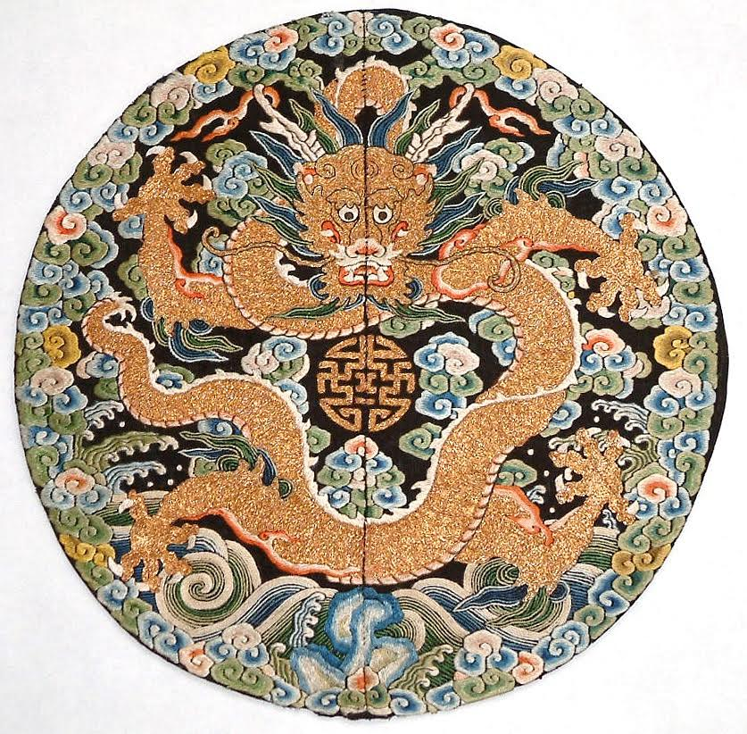

Details:
Location: China Exchange
Price: 6.00
Start time: exhibition from 5.30, talk at 6.30pm.

